Observer Pattern
# Source: AI Source: Provided by: [Data Path: Persons Table -> ID Column: 1, Name_En Column: Motasem Essam] -> From: [ChatGPT] on [1/23/2026]
The Observer Pattern defines a one-to-many dependency between objects, so when one object (the subject) changes state, all its dependents (observers) are automatically notified and updated.
👉 Think of it like a YouTube channel subscription: when the creator uploads a video, all subscribers get notified.

🔑 Key Points
# Source: AI Source: Provided by: [Data Path: Persons Table -> ID Column: 1, Name_En Column: Motasem Essam] -> From: [ChatGPT] on [1/23/2026]
• One subject and multiple observers
• Observers are automatically notified of changes
• Promotes loose coupling between components
• Common in event-driven systems

❌ Bad Example
# Source: AI Source: Provided by: [Data Path: Persons Table -> ID Column: 1, Name_En Column: Motasem Essam] -> From: [ChatGPT] on [1/23/2026]
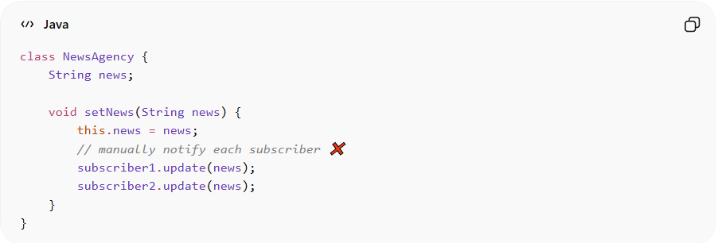
class NewsAgency {
String news;

void setNews(String news) {
this.news = news;
// manually notify each subscriber ❌
subscriber1.update(news);
subscriber2.update(news);
}
}
Problems:
• Tight coupling between subject and observers
• Hard to add/remove subscribers
• Not scalable

✅ Good Example
# Source: AI Source: Provided by: [Data Path: Persons Table -> ID Column: 1, Name_En Column: Motasem Essam] -> From: [ChatGPT] on [1/23/2026]
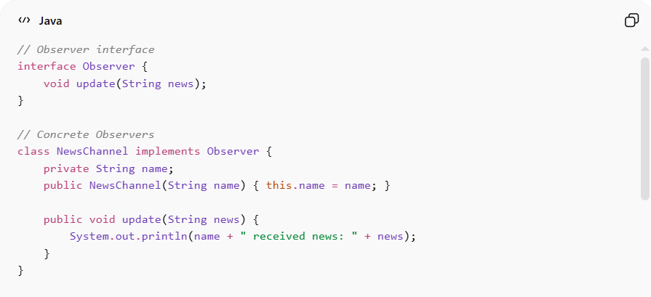
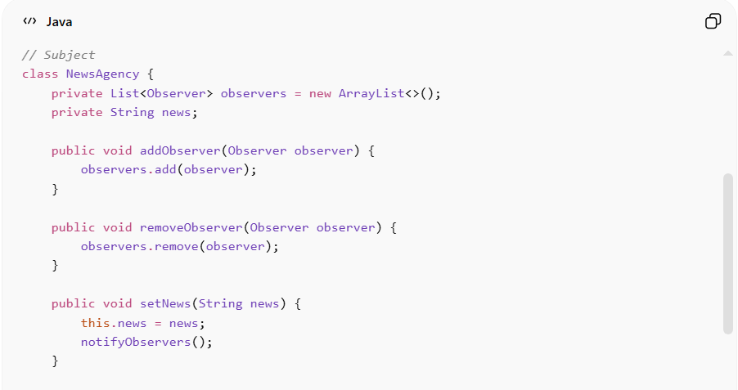
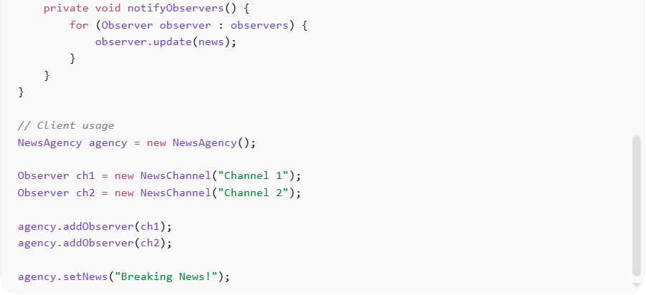
// Observer interface
interface Observer {
void update(String news);
}

// Concrete Observers
class NewsChannel implements Observer {
private String name;
public NewsChannel(String name) { this.name = name; }

public void update(String news) {
System.out.println(name + " received news: " + news);
}
}

// Subject
class NewsAgency {
private List<Observer> observers = new ArrayList<>();
private String news;

public void addObserver(Observer observer) {
observers.add(observer);
}

public void removeObserver(Observer observer) {
observers.remove(observer);
}

public void setNews(String news) {
this.news = news;
notifyObservers();
}

private void notifyObservers() {
for (Observer observer : observers) {
observer.update(news);
}
}
}

// Client usage
NewsAgency agency = new NewsAgency();

Observer ch1 = new NewsChannel("Channel 1");
Observer ch2 = new NewsChannel("Channel 2");

agency.addObserver(ch1);
agency.addObserver(ch2);

agency.setNews("Breaking News!");
Benefits:
• Easy to add/remove observers dynamically
• Promotes loose coupling
• Scales well for event-driven systems

⚡ Advantages
# Source: AI Source: Provided by: [Data Path: Persons Table -> ID Column: 1, Name_En Column: Motasem Essam] -> From: [ChatGPT] on [1/23/2026]
• Supports broadcast communication
• Promotes flexibility and extensibility
• Decouples subject from observers
• Ideal for real-time updates

⚠️ Disadvantages
# Source: AI Source: Provided by: [Data Path: Persons Table -> ID Column: 1, Name_En Column: Motasem Essam] -> From: [ChatGPT] on [1/23/2026]
• Can cause memory leaks if observers are not removed
• Too many observers can affect performance
• Debugging notification chains can be difficult

🛠️ Use Cases
# Source: AI Source: Provided by: [Data Path: Persons Table -> ID Column: 1, Name_En Column: Motasem Essam] -> From: [ChatGPT] on [1/23/2026]
• Event systems – UI events (button clicks, listeners)
• Notification systems – email, SMS, push notifications
• Stock market apps – price updates to subscribers
• MVC architecture – model updates notify views

